**Ch8.1 Assignment_WiFi**

**Name: Mark Van Wormer z1800639**

**Activity 1.** Understanding of WiFi Terms.

**Task 1.** Definitions. Find the definitions of the following terms from your textbook and use your own words to rephrase the definitions.

Example:

Access Point (AP)

-Book definition: a dedicated device or software running on a computer or any other device. The primary role of APs is to provide interconnectivity between Ethernet and WiFi through the translation of their frames.

-My definition: APs can be regarded as the intermediary devices or softwares that connect wireless devices to the wired LAN. In this way, the wireless devices can access the Internet.

a. Basic Service Set (BSS) (1 point)

-Book definition: The smallest building block of a Wi-Fi LAN. In the ad hoc mode, it takes minimum two stations. In the infrastructure mode, it needs at least one host station and one access point.

-My definition: Is a single building or block consisting of two stations when using ad hoc mode but at least one host and one access point in the infrastructure mode.

b. Service Set Identification (SSID) (1 point)

-Book definition: It is the identifier of a Wi-Fi network and is configured in the access point(s).

-My definition: Is how we identify a Wi-Fi Network and how it is configured in the Ap’s

c. Basic Service Set Identification (BSSID) (1 point)

-Book definition: Each BSS has a 48-bit BSSID to uniquely distinguish a BSS from other BSS. In the infrastructure mode, the BSSID of a basic service set is the access point’s MAC address.

-My definition: The BSS consists of a 48-bit BSSID which is unique to distinguish it from others BSS. The BSSID is the access points MAC address in infrastructure mode.

d. Extended Service Set (ESS) (1 point)

-Book definition: An ESS is composed of multiple basic service sets (BSS), each with a wireless access point and associated host stations.

-My definition: Is a collection of several BSS for example a university is an ESS as it is comprised of multiple BSS put together.

**Task 2**. Application.

Given a hypothetical corporate network as the following graph. Answer the questions based on the network **within the red-line boundary**. (4 points)

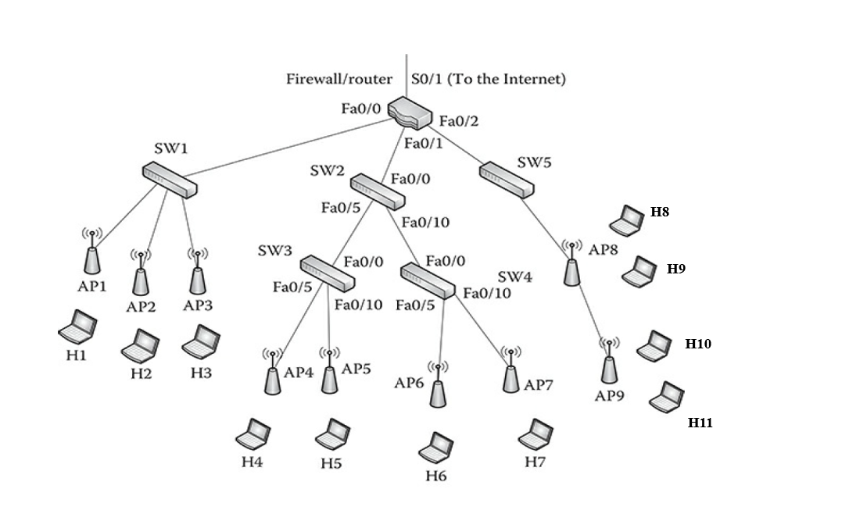

1. What is the smallest number of SSID(s) the network can have? Explain why.

1 SSID is the smallest number a network can have as it can go across multiple subnetworks.

1. How many BSS do you see within the red-line boundary? List **all** the components in **each of the BSS**.

6 BSS in the red boundary. AP4->H4, AP5->H5, AP6->H6, AP7->H7, AP8->H8/H9, AP9->H10/H11

1. How many ESS do you see within the red-line boundary? Explain why.

There are 2 different subnetworks in the red boundary. Each subnetwork is an ESS so in that logic there are 2 ESS in the red boundary.

**Activity 2.** Using Xirrus WiFi inspector to test NIU WiFi

Download and install Wi-Fi inspector from Xirrus (https://www.techspot.com/downloads/6901-xirrus-wifi-inspector.html). Familiarize yourself and understand how the WiFi inspector works. Answer the following questions.

1. What is your current IP address? Convert it to the binary address (a sequence of 0s and 1s). (1 point)

10.166.82.18

00001010.10100110.01010010.00010010

1. Investigate the radar image. What does the distance between certain SSID(s) and the center point indicate? (1 point)



I believe the center point indicates your device (such as this laptop) and it indicates the distances to different networks SSIDs available near your device location.

c. Describe how would you locate an access point despite the limitations of the radar window? (Only a written short answer is required. It is an open question. No absolute correct answer.) (2 points)

d. What kind of information you can learn from the connection test and the speed test? (2 point)

The Information you obtain from a connection test is to test if your internet level connection. In contrast a speed test will give you an analysis of internet access performance metrics such as latency.

e. Go to 5 places within the Barsema Hall building. At each location, 1) record the information in the networks window, 2) conduct and record the connection and speed tests, and 3) take a selfie to indicate your location 😊 (Specify the location, then post the relevant screenshots and your selfie). (5 points)

Barsema Hall 333

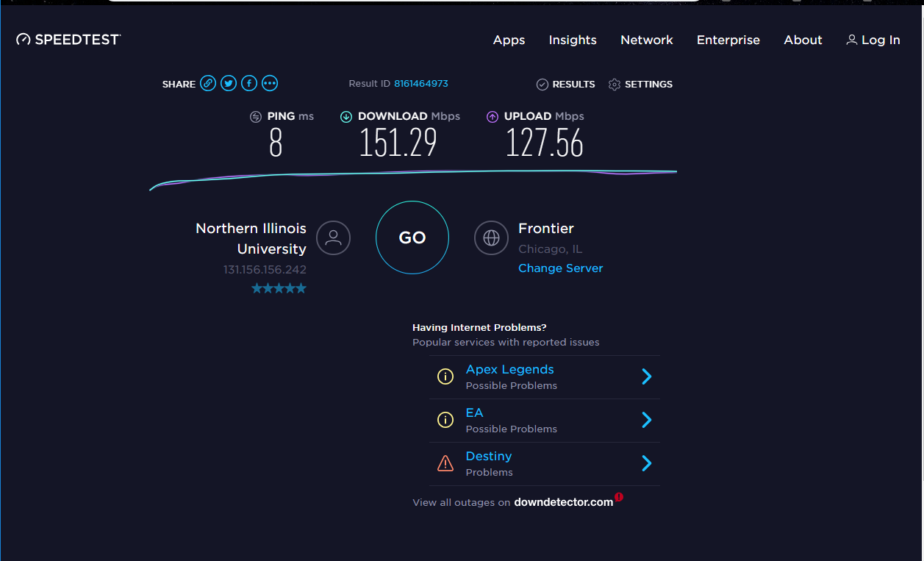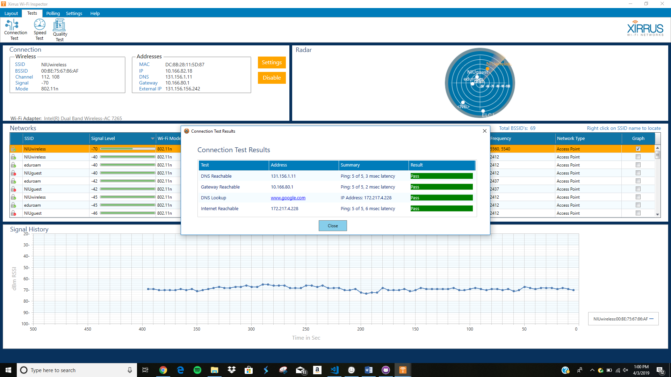

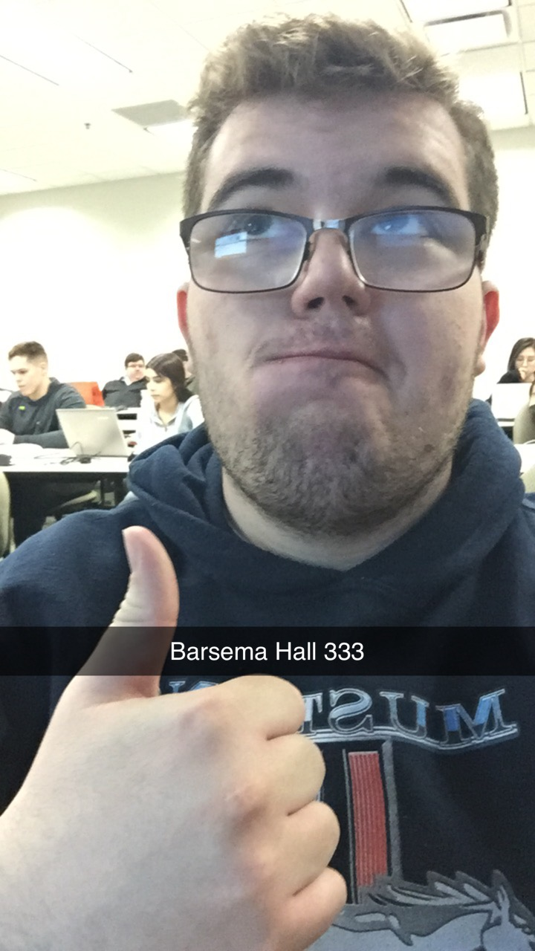

Barsema Hall 328

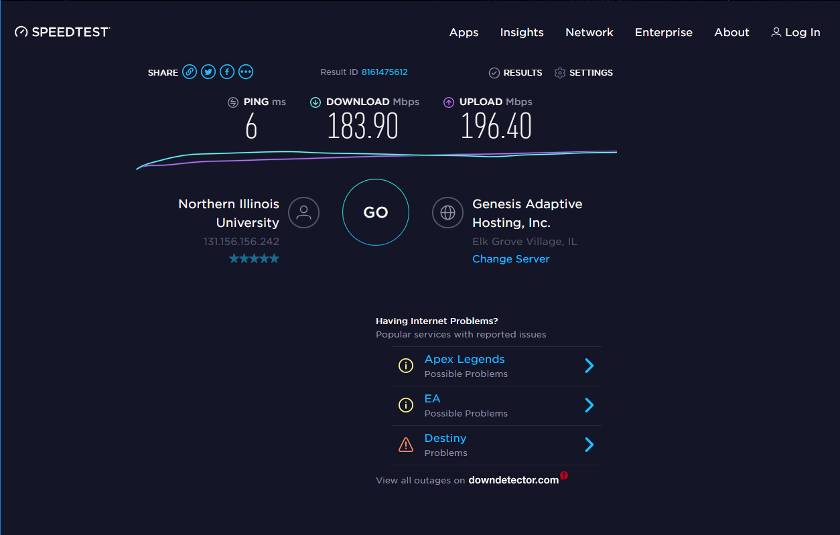

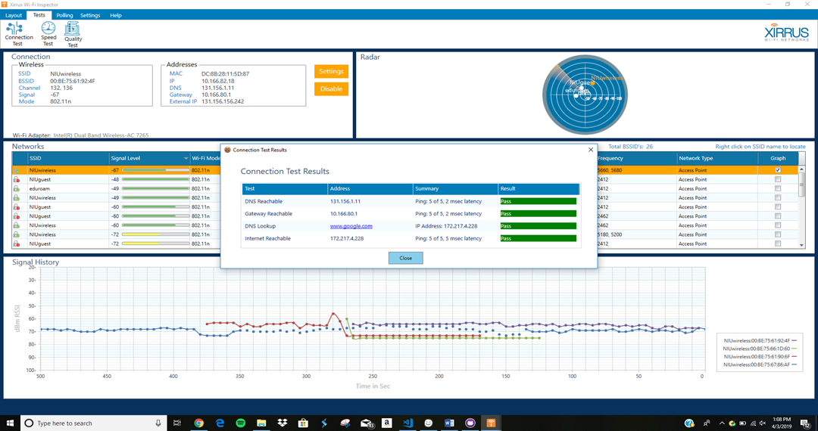

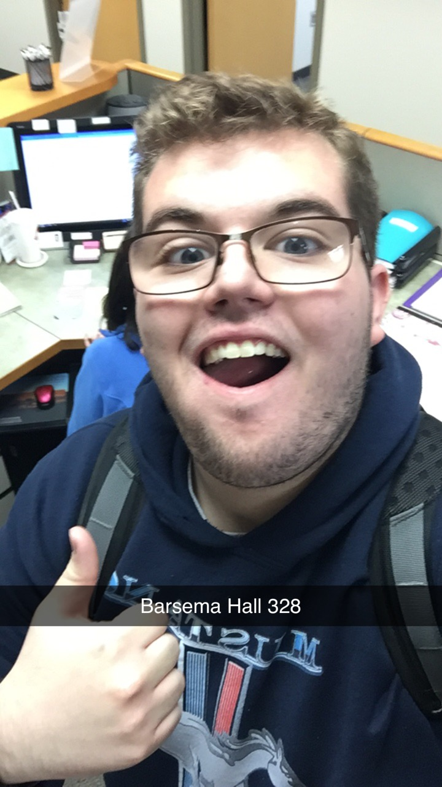

Barsema Hall Atrium (By the Windows)

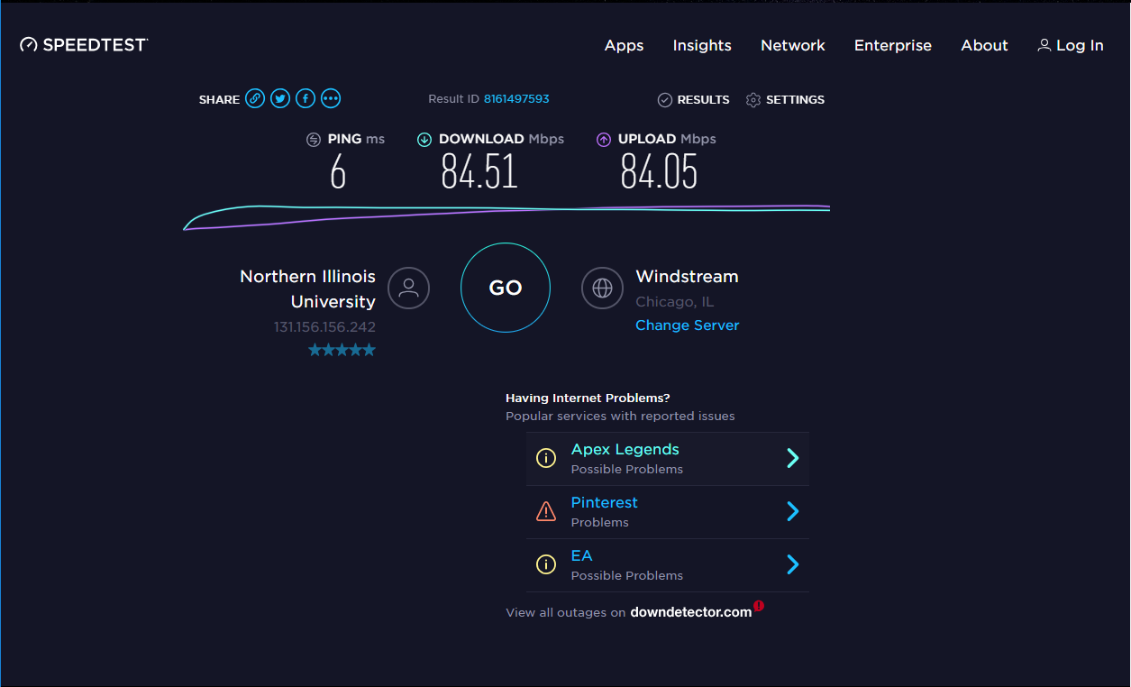

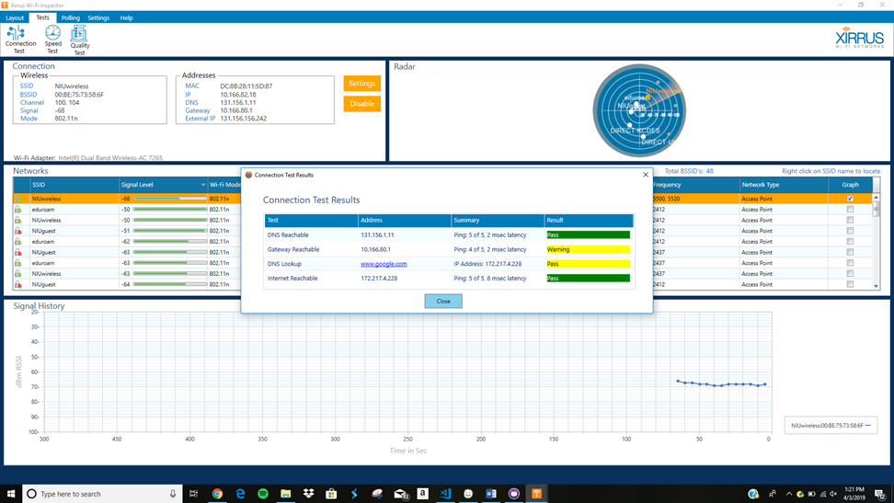



Barsema Hall Men’s Bathroom (1st Floor)

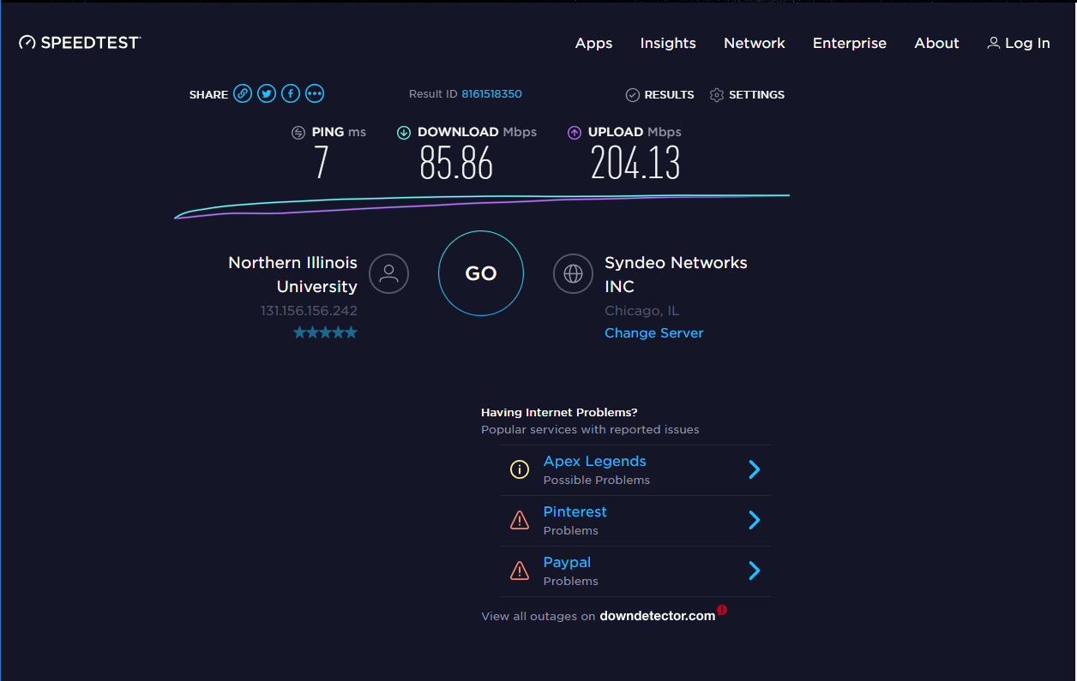

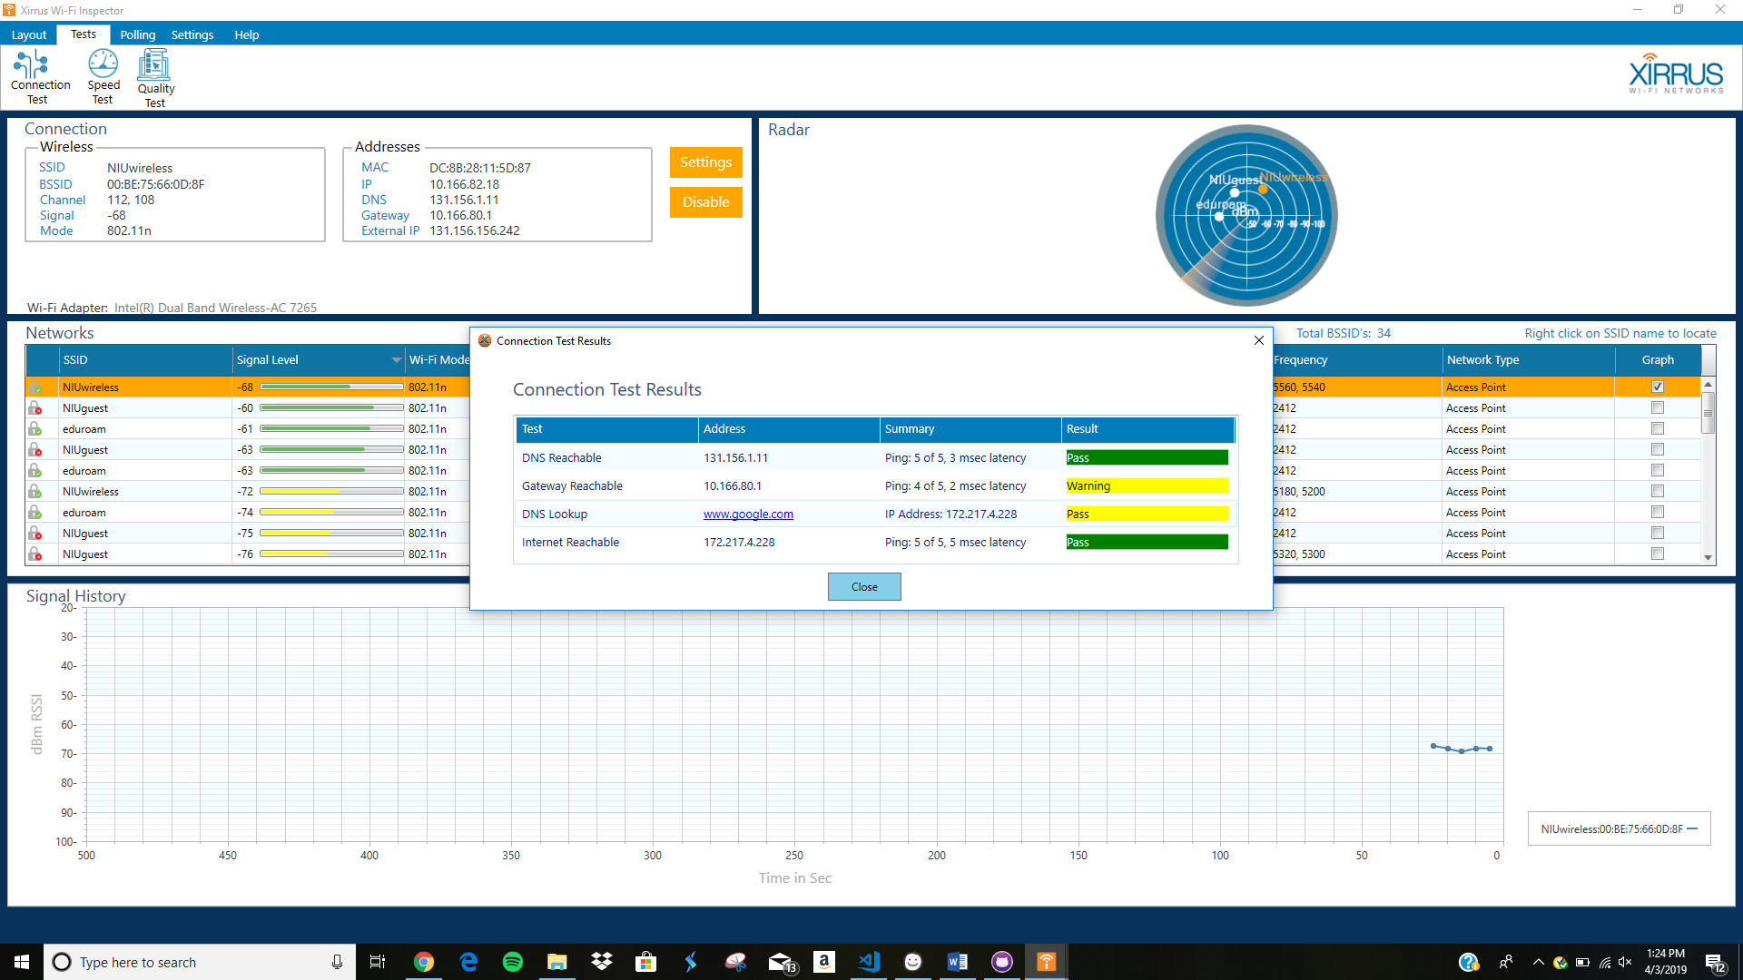



Barsema Hall (Vending Machines)

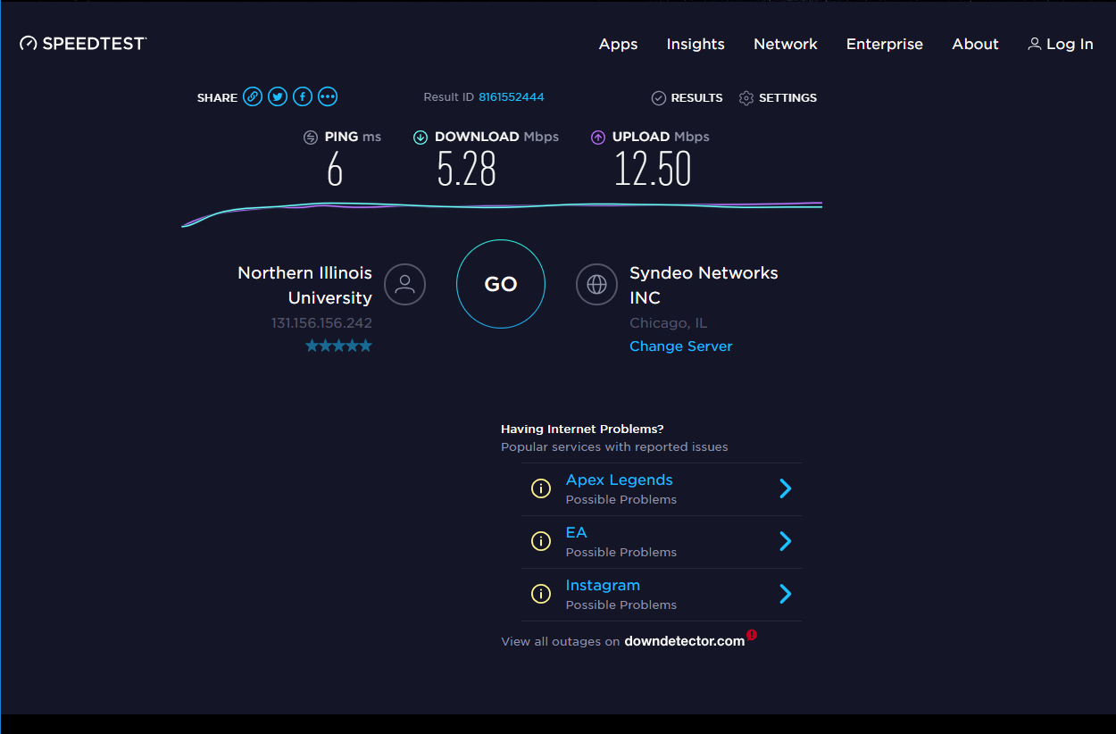

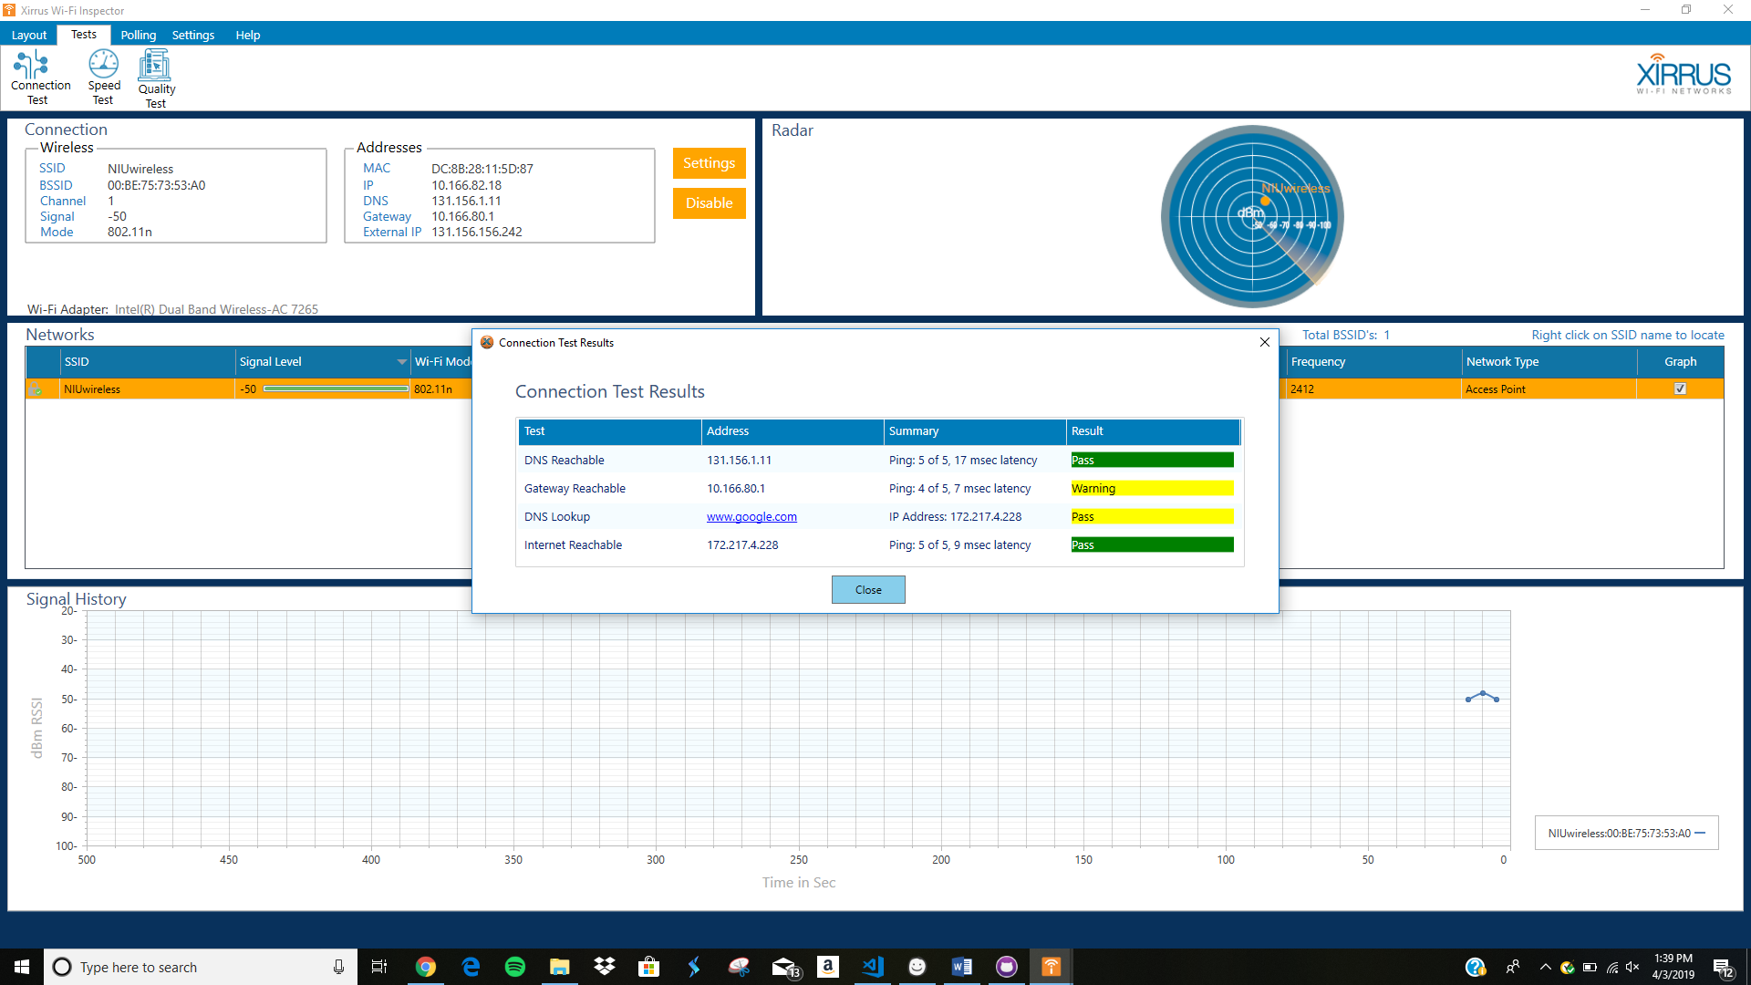



f. Write a summary describing the WiFi service and quality in the Barsema Hall building, referring to the data you have collected) (1 point)

The wireless in Barsema Hall tends to vary based on what floor you’re on. For example, on the first floor WiFi tends to be a bit slower and spottier if you are in an interior portion of the building but over where its more open it seems to be okay. Second and Third floors again it all depends on where you are and how many people as there are a lot of people connected to the NIUwireless it tends to slow it down